**A CRM Application to Manage the Mall**

College Name : RVS TECHNICAL CAMPUS COIMBATORE

College code:7129

Department : Computer Science and Engineering

NM Project : A CRM Application to Manage the Mall

**Group project**

**TEAM ID :** **974626C67D2CC8290634BC63E39DC6AE**

* S.PRAVEEN NM id:au712921104038
* J.SIVA NM id: au712921104051
* E.BOOPATHY NM id: au712921104301
* N.ABDUL KAREEM NM id: au712921104001

**About The Project:**

**Salesforce CRM**

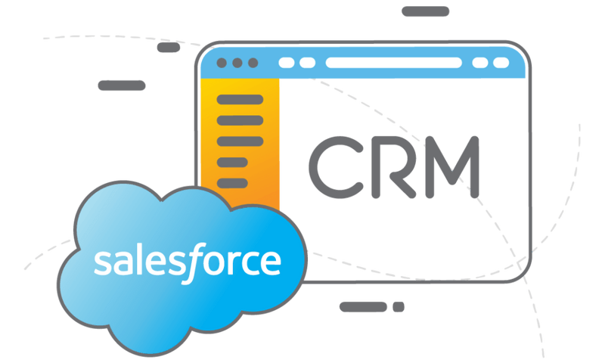

Salesforce is a cloud-based Customer Relationship Management (CRM) platform that enables businesses to manage customer data, sales operations, and marketing campaigns.

Customer relationship management (CRM) is a technology for managing a company's relationships and interactions with all of its customers and potential customers. The goal is simple: Improve business relationships.

A CRM brings your teams together, sharing information that makes everyone's job easier.

**SmartMall:**

We Created CRM Application Named SmartMall

This SmartMall we can manage the Mall

This SmartMall Appliction can manage the tenant and tenant issues ,reports and dashboards

**To Create the SmartMall**

Creating Salesforce Developer Account <https://developer.salesforce.com/signup>

Creating The Custom Object for the CRM Application

Object Names are Tenant,Tenant Issues,Lease Tracking

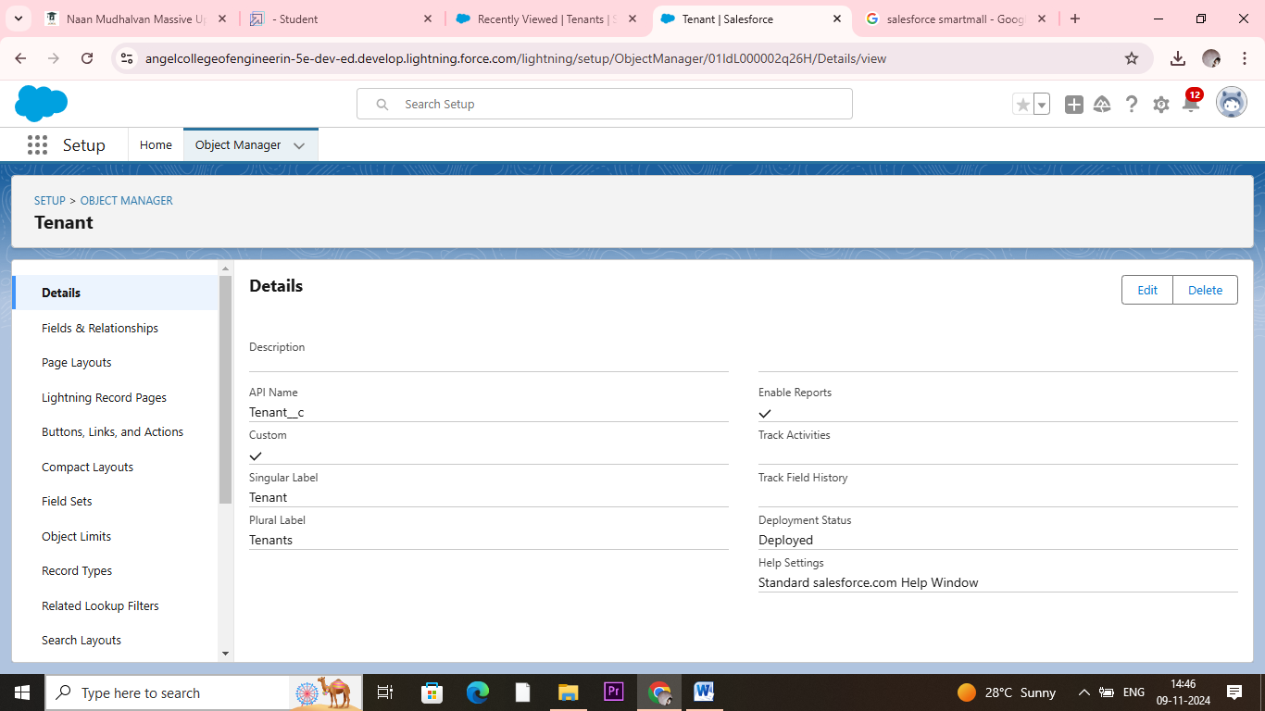

And Create Custom Tab in Salesforce Application for Each Objects.

Create the Fields and Relationships to the Each Objects

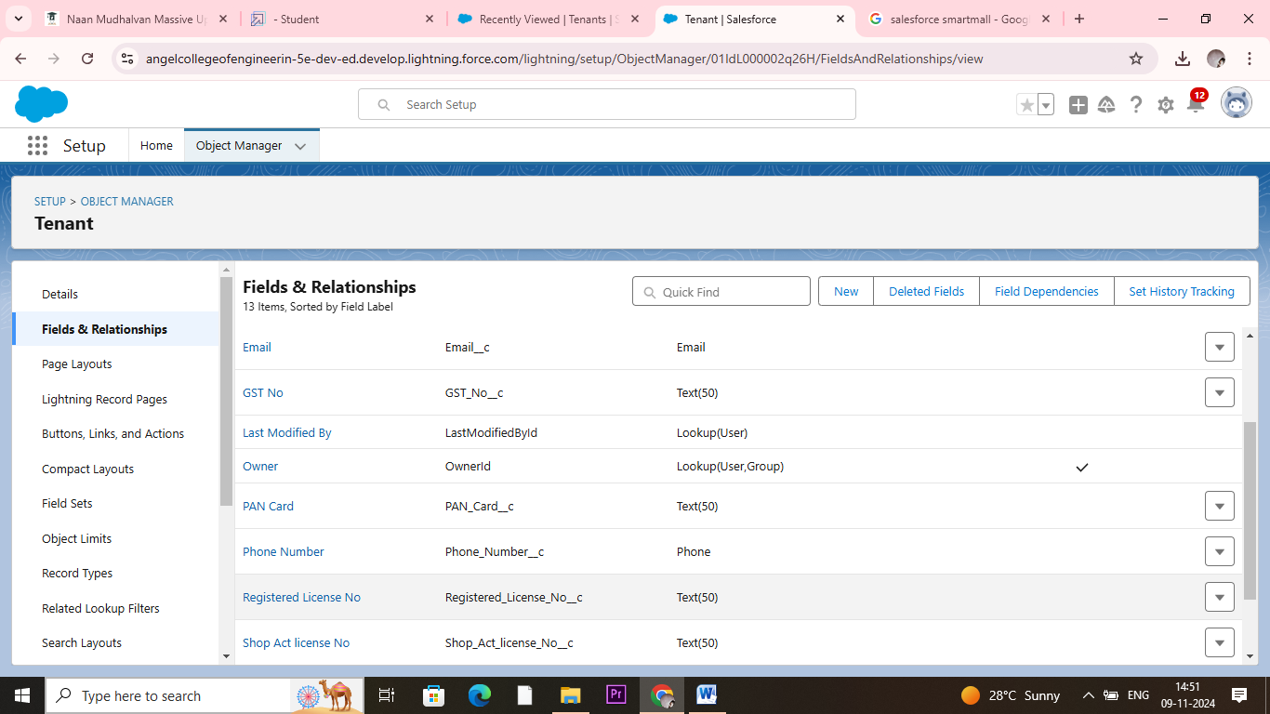

**Create the Lightning App**

An app is a collection of items that work together to serve a particular function. In Lightning Experience, Lightning apps gives users access to sets of objects, tabs, and other items all in one convenient bundle in the navigation bar.

There are two types of Salesforce Applications:

Standard Apps

Custom Apps

In This step we named the Application into SmartMall

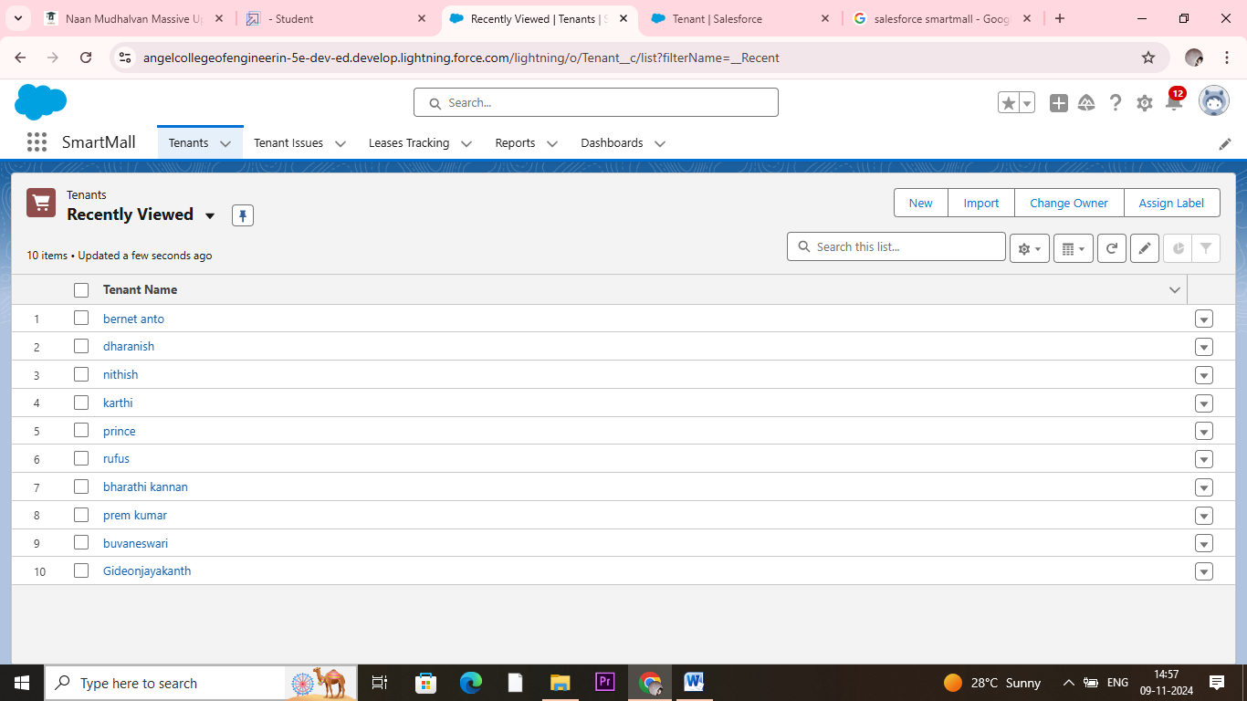

After Insert the records to the created objects.

**Create Flows**

In Salesforce, a Flow is a powerful tool that allows users to automate complex business processes by orchestrating and automating sequences of tasks, data manipulations, and user interactions. Flows are designed through a visual interface, making them accessible to users with varying technical expertise.

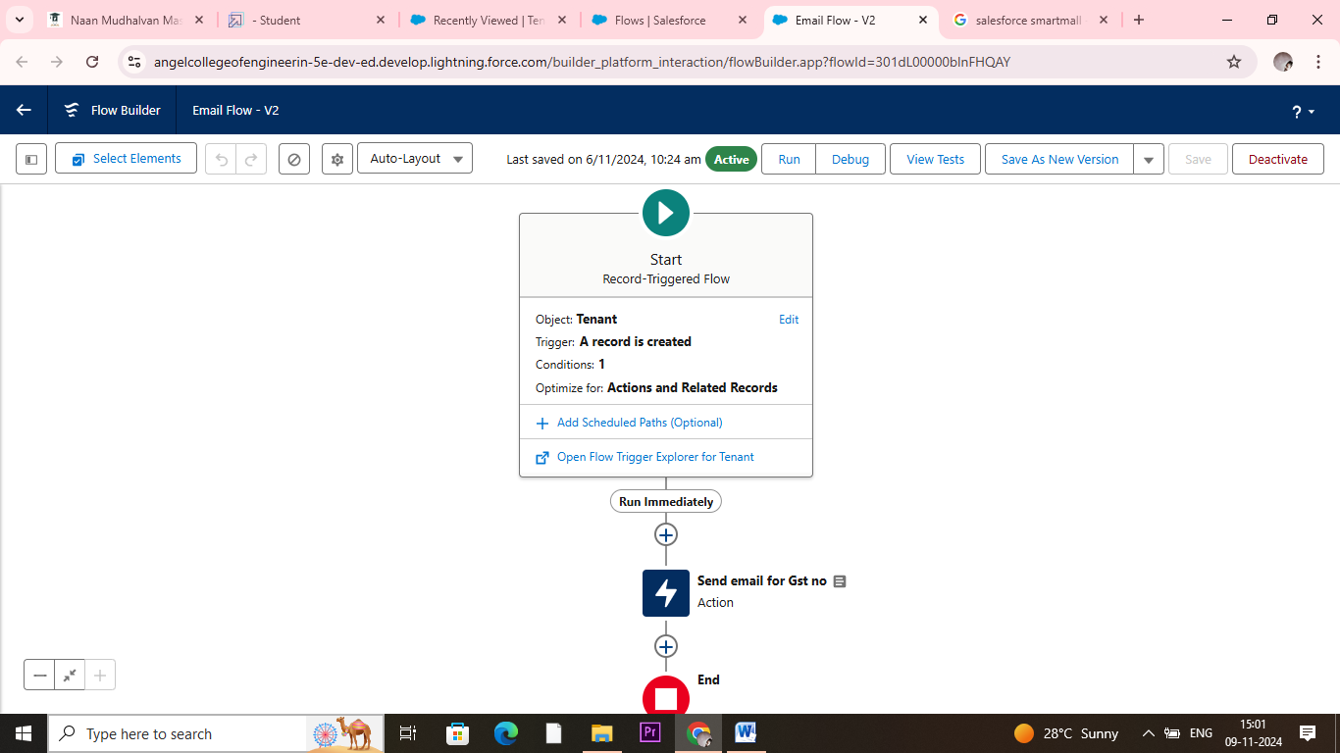

We created two flows for Tenant objects and Lease Management objects

For Email message send to customers enquiry.

**Apex Triggers**

A trigger is a set of Apex code that runs before or after DML(Data Manipulation Language) events.

A DML event could be a variety of data processing tasks that include the standard insert, update, and delete commands.

In our project we used apex trigger to run the project email confirmation

Code for Email

CODE SNIPPET :

trigger leasetrackingtrigger on Lease_Tracking__c (After insert,After update)

{ if(Trigger.isAfter && Trigger.IsUpdate)

{

LeaseTrackingTriggerHandler.method1(trigger.old);

}}

Code for Pan card:

public class TenantTriggerhandler {

public static void method1(List<Tenant__c> te)

{

for(Tenant__c tenant : te)

{

if(tenant.Pan_Card_no__c.length() > 10)

{

tenant.addError('This Pan Card number is invalid, Please Enter Valid Pan Card number');

}

}

}}

**Asynchronous Apex**

Delete the Tenant Records Monthly whose Status Of Possession is closed.

1) Create a class with name tenantschedulable

2) Give extension Schedulable to the class.

3) Open the Anonymous Window.

4) Schedule the class-

CODE SNIPPET : -

public class tenantschedulable implements Schedulable

{

public void execute(Schedulablecontext sc) {

list<Tenant__c> ten = [SELECT Id, Status_of_Possession__c FROM Tenant__c ];

list<Tenant__c> tenantstodelete = New List<Tenant__c>();

for(Tenant__c te: ten)

{

if(te.Status_of_Possession__c == 'Closed')

{

tenantstodelete.add(te);

}

}

Delete tenantstodelete;

}

}

**Create Reports And Dashboards**

Create a Report of lease Management Records

The Manager needs a report which shows the tenant and their joining date and their Remaining payment details and also group this by date of Registration, and make a bucket list of remaining amount as greater than 1000000 as red, less than 1000 and greater than 500000 as blue and less than equal to 500000 as yellow.

Create a Report on Tenant issue Records

Now the manager is asking for a report on issues which has not been contacted or Open yet and has high priority which are directly encountered by Phone and Mail and the date of issue is from last 7 days

Create a Report on Tenant Records

Now, The Manager wants a Report which shows all the pending possessions and also shows the tenant’s Pan Card no and GST NO and group date of reg by column and row by Status of Possession.

Create a Dashboard

Very Good, You have created multiple reports but now for better convenience the owner wants a Dashboard which shows the data of these reports

This image shown reports

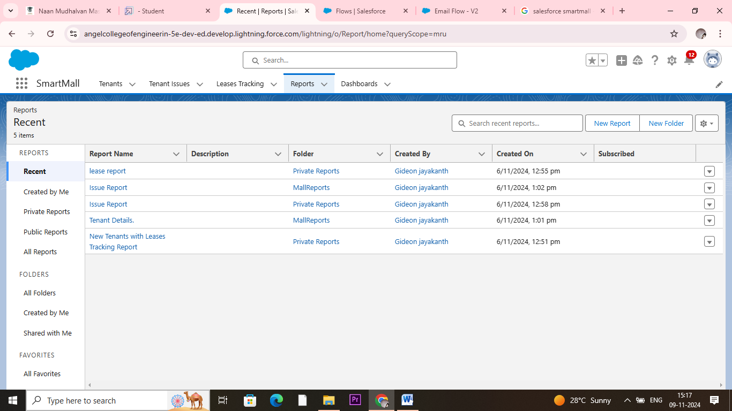

This image shown dashboard

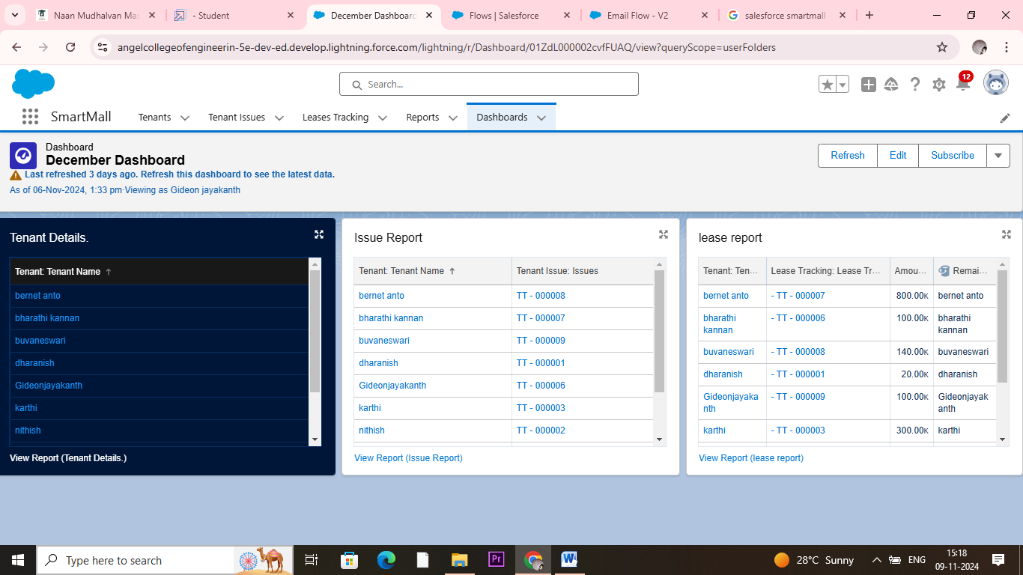

This is the Final report of our project A CRM Application to Manage the Mall has been created and Executed successfully